How to submit an infographic.

Either design your own or use the templates provided on power point. There are three of them to select from.
Click on the one you want to download:
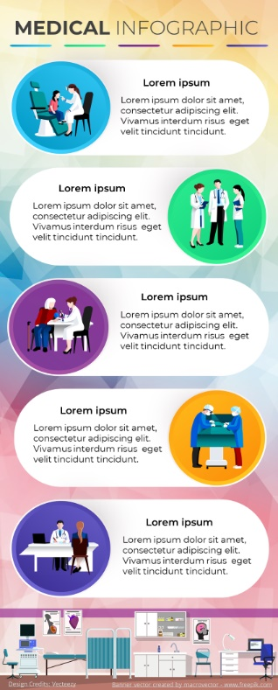
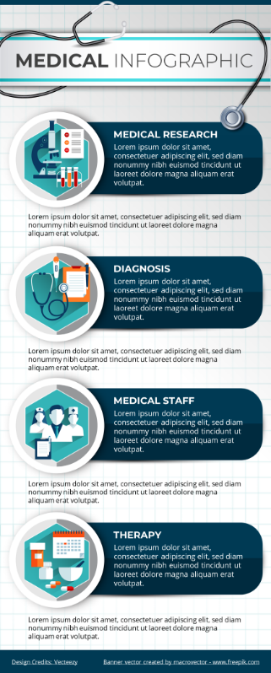

Each also offers icons and backgrounds that you can use for your design. If you choose your own graphics or images please make sure you own the copyright to these images and provide proof of ownership at the time of submission.
Having completed the infographic save it as a Jpeg file and size to exactly 600 x 1488 pixels.
Upload the infographic with a note for the editor. Your submission will be peer reviewed before being accepted for publication and you may be asked to make changes before it is accepted.

